How to Get Into Fights With Data Centers:

Or, a Modest Proposal for Reframing the Climate Politics of ICT

Also: how to use ping and traceroute to find the location of data centers, and how to look for DRAMA, CONFLICT, and OPPORTUNITIES TO ORGANIZE WITH OTHERS wherever you find them

===

## Acknowledgements:

I’m further grateful for Mél Hogan, Dawn Nafus, Dawn Walker, Tim Cowlishaw, Brian Sutherland, Stefan Laser, Alex Nathanson, Benedetta Piantella, Tega Brain, Andre Rosario/ hydroponictrash.solar and all my fellow travelers in the study of the material impacts of digital systems for their advice, research, and community. It’s been a real pleasure to be in conversation with you all. Thanks also to Juniper Mitchell, Mel Gregg, Alex Bruneau, Marije Miedema and Ed Platt for being my invaluable test readers and Swati Mehta for some stellar copy editing.

## Suggested Citation:

Pasek, Anne. “How to Get Into Fights With Data Centers: Or, a Modest Proposal for Reframing the Climate Politics of ICT.” White Paper. Experimental Methods and Media Lab, Trent University, Peterborough, Ontario. 13 June, 2023. July 2023. https://emmlab.info/Resources_page/Data%20Center%20Fights_digital.pdf.

A brief note to the reader: This zine is an attempt to package up some long-running academic ideas of mine into a more accessible format, sparking a conversation and teaching a few new skills. If you want to geek out further, I encourage you to follow the links, many of which point to open-access (which is to say free) academic articles. My goal for now, however, is ease up on some of the jargon and hedging that you find in that genre of writing. I hope that, whoever you might be, you’ll find this zine easy to read, useful to your thinking, and respectful of your intelligence. You can let me know how I did (if you’d like) at [annepasek@trentu.ca](mailto:annepasek@trentu.ca).

====

# What is the carbon footprint of our digital lives?

I made this zine because I keep getting asked this question. There’s a growing number of people and organizations who are anxious about climate change, aware that digital stuff plays a role in that, sincerely want to do something about this in their personal or professional lives. Sometimes it’s artists wondering if their creative practices online might be producing outsized harms. Sometimes it’s small organizations looking to find internal policies for email or file storage that can strike a balance between utility and ecological sufficiency. At other times, it’s colleagues of mine in academia, looking to embrace lower-carbon ways of working, connecting, and archiving, all with an eye to the steadily rising amount of digital stuff in the cloud and CO2 in the air.

It's encouraging to see so many people pose this question. I’m part of a community that studies the energy and carbon impacts of digital networks, and it used to feel like our biggest challenge was just getting people to understand that online files and services aren’t the immaterial stuff of sleek corporate infographics or the whole metaphor of ‘the cloud.’ That cloud, we’d endless reply, is just someone else’s computer. Most likely, it’s a computer stuck in an enormous data center somewhere sort of rural, where it consumes impressive amounts of electricity (to power the facility) and water (to cool down all those hot servers).

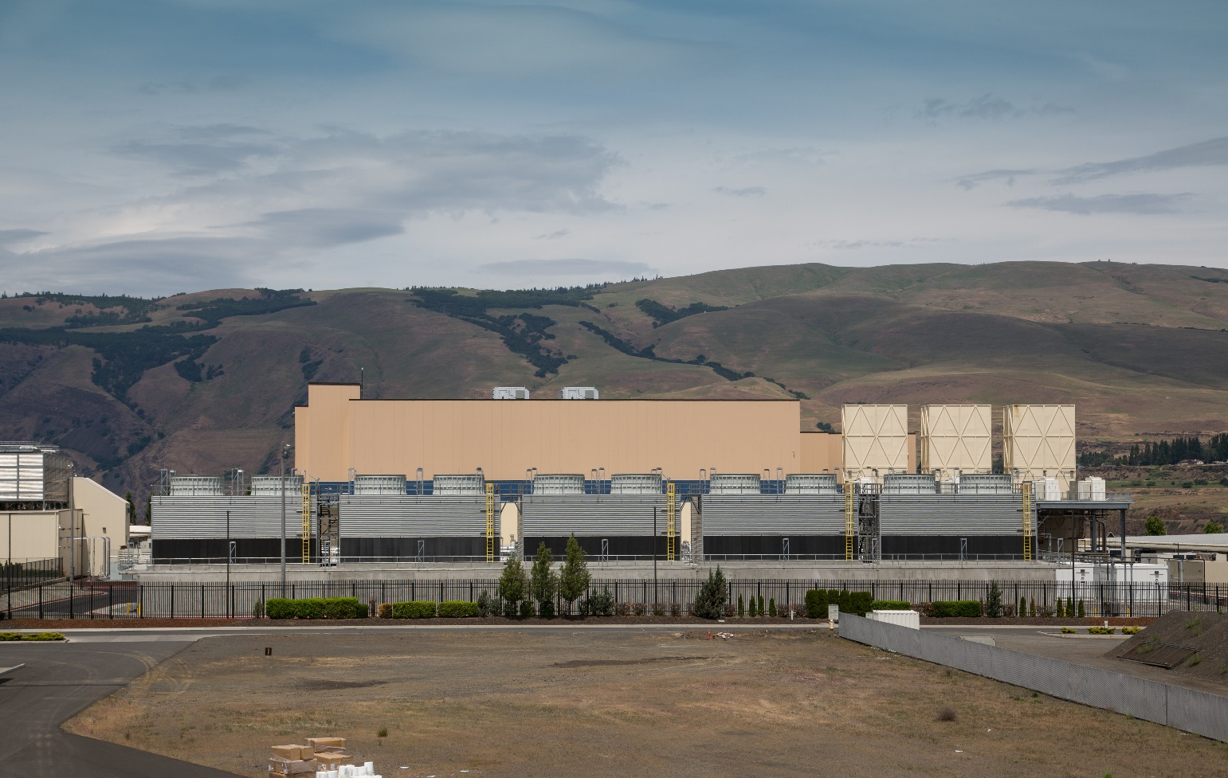

To give an example, take Google’s data center in Dalles, Oregon. It cost more than $1.8 billion to build and is several football fields wide. The facility uses more than 350 million [gallons of water](https://www.oregonlive.com/silicon-forest/2022/12/googles-water-use-is-soaring-in-the-dalles-records-show-with-two-more-data-centers-to-come.html) (almost a third of the total water use for the city) and more than 310 million [kWh of electricity](https://www.oregonlive.com/silicon-forest/2011/09/google_divulges_data_center_power_usage.html) (more than 2/3rds of the electrical demand for the whole utility district). That’s a lot—especially considering Google’s often better than a lot of its peers on sustainability stuff. Worryingly, Google has strived, through non-disclosure agreements and legal battles, [to keep past and potential future water rates secret](https://fortune.com/longform/google-data-center-the-dalles-oregon-water-dispute/).

So how bad is the problem, really? Estimates put the ICT sector somewhere between [2-4](https://arxiv.org/abs/2102.02622)% of all the carbon emissions produced each year across the planet (not including crypto). That’s not insignificant, but it’s also not apocalyptic. I like to tell people that it’s a ‘medium sized problem.’ However, there are bigger concerns and uncertainties about the future trajectory of the sector. Researchers disagree about whether or not the carbon emissions of digital systems are [growing just a little](https://www.ericsson.com/en/reports-and-papers/industrylab/reports/a-quick-guide-to-your-digital-carbon-footprint) or are set to [explode](https://theshiftproject.org/wp-content/uploads/2019/03/Lean-ICT-Report_The-Shift-Project_2019.pdf) in future years. (Personally, I think the extreme estimates on either end are dubious). But whatever way you look at it, if the sector wants to keep pace with the wider climate commitments of the Paris Agreement, it will need to reverse course and reduce emissions. That requires changing norms and habits—probably both for consumers and industry players.

This circles back to the question of digital carbon footprints. It’s normal for us to want to think through sustainability problems with the assistance of a little quantification. There’s even a growing number of online calculators to help you assess exactly how bad your own digital emissions might be.[1] If you’re sending an email, watching a video, or archiving your data in a cloud back up, you can find a carbon number for your actions.

The trouble is, I think that this is often the wrong question to ask—at least in terms of the carbon costs of discrete consumer action.

A nerdy network aside: Why am I so skeptical about these tools? In part because *calculators use a lot of assumptions that make their outputs look way more precise than they actually are*. All the footprinters you can find online have to make approximations about the carbon intensity of electricity, the kind of devices you’re using, the efficiency of the wider network, and the path your data takes across it. All these factors fluctuate over time and place, so what these tools can calculate is really just an estimate from a model—not a ‘true’ answer.

But more importantly, *these answers give us the wrong impression about how to actually reduce emissions*. We’re used to thinking about carbon footprints in a certain way: one where the connections between our consumer habits and environmental impacts are pretty direct. We all know the script: if we want to make the number go down, we need to consume less.

This makes sense for stuff like car travel or beef, but it doesn’t hold true in the same way for network data. This is because, for information to travel across our networks, much of the equipment that makes up that network needs to be always on, always available. Its electrical draw is fixed—it consumes the same amount regardless of how much data is moving through the figurative tubes. When you use a calculator to estimate the carbon footprint of streaming, sending, or storing something, it takes a guess at a commensurate share of all that energy consumed by the networks entangled in that action. However, this doesn’t mean that swearing off Netflix will actually result in a commensurate reduction in the network’s electrical use or its resulting climate impacts. The network is going to stay on; the data centre hosting that video will still draw the same amount of power.

This is really frustrating! It means that our first impulse, to focus on our own actions and to ask how we can better align them with our ethics, isn’t a terribly useful starting point for learning how digital networks actually work or how to change them. In fact, I worry that it risks teaching the wrong lessons, leaving us with an inflated sense of our individual importance and agency. It’s kind of the same mistake that we’ve made with [plastic recycling](https://discardstudies.com/2012/09/20/recycling-as-a-crisis-of-meaning/): we can be overinvested in the morality of individual actions, completely missing how larger industrial factors have a far bigger impact.

But wait, surely consumer demand counts for something! You could argue that withdrawing your participation from digital businesses that have an outsized impact on the climate has still got to be at least a little helpful. Even if it doesn’t lessen the immediate carbon intensity of our digital systems, maybe it’ll reduce the market signals for these kinds of businesses, such that they’ll slow or reduce their operations. Voting with your dollar counts, right?

Well sure, but just like voting in general, you’ll only win things if you have real numbers behind your cause. A coordinated boycott is likely necessary to have much of an impact. [Greenpeace](https://www.greenpeace.org/international/publication/6826/clicking-clean-2017/) sort of gestured at the possibility of one a while ago, but no one ultimately ever hit the ‘boycott’ switch (and in fact their campaign focused almost as much on consumer loyalty and appreciation as it did on environmental concerns). Boycotts could be a tactic worth trying again in the future, but we’d definitely need lots of friends and allies to pull it off.

# What’s a better question?

These days whenever I’m asked what the climate impact of X network thing might be, I pivot and instead try to start a conversation about how we can stop the next data center from being built.

(Think of those ‘one less car’ stickers you see on commuter bikes, but with a digital twist.)

I like this frame because it

1. Makes it a collective, rather than individual, concern (*goodbye and good riddance, green saviour complex*);
2. Keeps our focus on the infrastructure rather than the content (*and so maybe helps avoid some unhelpful moralism about what kinds of content are ecologically and morally justified)*;[2]
3. Encourages us to think about sufficiency and degrowth (*which is to say, we aren’t against digital networks in the general, just against their unthinking expansion*);
4. Encourages us to keep the relative scale of things in mind, rather than just our personal actions (*i.e. ChatGPT emits way way way way way way way more than your cat photos ever will*);
5. Centers our attention on particular places and communities where specific and disproportionate impacts will be felt (*rather than only the global abstract of the climate—though I care a lot about that too*);
6. Opens the door to exciting coalitions (*see the box above about the need to make friends in order to win things).*

Of course, this perspective also leaves some stuff out. This might include:

- improvements we could make to network and software efficiency,

- potentially quite helpful green power purchases by big tech giants, or

- environmentally beneficial uses of big chunky data sets and machine learning tools.

I have my suspicions about the sufficiency of these strategies without a bigger picture focus on degrowth, however.[3] What’s more important, though, is that these areas are mostly matters of internal corporate policy and expertise rather than broad civic engagement. If you, as an individual or non-tech organization, are looking for a place to dig in, I’d like to suggest that the best place to do so is around resisting data center expansions.[4]

# But why data centers?

Great question. Data center construction has been booming for the past decade or so, with demand predicted to [grow a continuing 10% per year](https://www.datacenterknowledge.com/dcim/catching-data-center-construction-constraints) through 2030. Right now, there are active plans in the works to build at least [300 more hyperscale facilities](https://www.datacenterfrontier.com/cloud/article/11427486/after-record-growth-in-2021-data-centers-are-building-bigger-for-2022). If all those data centers get built, that will lock in many cities’ worth of water and electricity consumption (even if they are ultra efficient state of the art ecological angel facilities).

This is on top of all the data centers we’ve already got kicking around—and they’re growing too. By some estimates, there are [8,000](https://www.usitc.gov/publications/332/executive_briefings/ebot_data_centers_around_the_world.pdf) or so in the world today, and many of these are slated for further expansions. It’s common for tech companies to build these sites with growth in mind, adding additional buildings and servers over time as demand continues.

Why are data centers booming? It’s true that the pandemic did hike the use of network services while many of us stayed at home (and in some cases, continue to do so today). However, the relationship between supply and demand with data centers is much weirder than this story might imply. Instead, as [Mél Hogan](https://www.academia.edu/39043972/The_Data_Center_Industrial_Complex_forthcoming_2021_) argues, there’s something of a self-fulfilling prophecy in the sector: tech executives work hard[5] to continually produce increasing amounts of cheap data storage, believing that this excess capacity is necessary to meet the needs of emerging business cases for cheap data storage. Sure enough, those often business cases often follow, but it’s not clear that they would have created that demand without the supply already being promised at bargain prices. It’s a chicken and egg thing—or, as Mél puts it, a “solution in search of a problem.”

We see that ‘solution’ evidenced today in the rise of many varied data- and compute-intensive applications. Things like ChatGPT, companies that act as ‘prospectors’ running analytics on massive health datasets, or general web3/crypto weirdness all wouldn’t be possible without the guarantee of cheap data storage. We live in a digital world increasingly defined by this presumption. It all adds up to far greater climate impacts than personal consumer habits alone.[6]

Who does this boom benefit? Those aforementioned tech executives, to be sure, along with the holders of stock options and judiciously invested venture capital. But, when it comes to the communities that have to live with all this digital infrastructure, the picture is much murkier. It’s often the case that different counties are enticed to compete with one another to offer more and more lucrative tax incentives to companies that might build a data center in their city. This results is a bit of a [race to the bottom](https://www.nytimes.com/2016/08/27/technology/cloud-computing-brings-sprawling-centers-but-few-jobs-to-small-towns.html), where property tax revenues from these facilities can run rather gaunt. Employment benefits are also minimal; after the construction work of a new facility is done, data centers don’t hire many local people. What’s more, for the many ‘internet landlords’ leasing server space to tech companies that don’t build own their facilities (which is to say, most of them), [tax breaks and loop holes](https://doi.org/10.1177/03063127221124943) let them avoid hundreds of millions of dollars each year in income tax. Taken together, data centers often look like they take more than they give.

These are a few of many reasons why I think we should all try to get into at least one fight with a data center. It will be salutary for our sense of scale, our climate feelings, and our ability to build coalitions and organize across various local and regional political concerns. If we can stop the next data center from being built (or endlessly expanded), and if we can create a wider movement contesting the social and ecological licence of these facilities, we can directly impact the climate trajectory of the tech sector overall. And, even if we fail, raising a fuss increases the likelihood of winning better economic concessions and legal regulations for these things down the road.

# But which data centers?

My first answer here would be to look into the data centers near where you live and work. If there’s a facility in your community (or plans to build one soon), it will likely impact you and your neighbours in some way. Data centers can affect your local [water table](https://www.datacenterfrontier.com/special-reports/article/11428474/tackling-data-center-water-usage-challenges-amid-historic-droughts-wildfires) (especially if you live somewhere prone to drought), [electrical prices](https://denisnaughten.ie/2022/03/28/data-centres-pushing-up-electricity-costs-for-families-naughten/), and the likelihood of [black outs](https://www.zdnet.com/article/massive-data-centre-demands-could-lead-to-power-blackouts-warns-irelands-utilities-regulator/). They can also cause deeply unpleasant (and unending) [noise pollution](https://www.datacenterdynamics.com/en/news/chicago-residents-complain-of-noise-from-digital-realty-data-center/) to people and animals that live close to these sites. As someone living in the wake of these structures, and (likely) as a political constituent of the region, you’ve got stakes and sway in that fight.

What if your local area is data center free? Well, you’ve still got plenty of relationships with data centers, stretching out to plenty of regions, you could tap into. The cloud, as you’ll recall, is just someone else’s computer. Let’s explore where those computers are by tracing your data back to its resting place.

Finding Where Your Data Lives[FUN ACTIVITY/TECH DIGRESSION STARTS HERE]

STEP 1: PICK A TARGET

Pick something online that’s meaningful to you—that thing that you’d otherwise be wanting to calculate with a carbon footprinting tool and wring your hands over. Maybe it’s your go-to website for passing the time, an online project you built, your meme stash, a web3 hate-watch, or your favorite multiplayer game. Anything with a URL or IP address will work.

What’s an IP address? It’s a set of 4 numbers that works like a ZIP/postal code for the vast mail system of the Internet.[7] IP is short for Internet Protocol, which are a bunch of rules written in the early days of the Internet to ensure that your requests and replies across the internet all eventually go where they should, even if they take different paths across the middle of the network.

STEP 2: PING TO GET YOUR IP

If you don’t already have an IP address, we’ll start with a simple ping command. This is a way to sort of ‘knock on the door’ of a website, get that IP address, and see if someone’s home. To do so, we’ll use a terminal program (if you’ve never touched one before, prepare to feel like a very cool hacker type).



NB: I’m going to use Castlefield Gallery’s website as my example here because I first developed this activity for a workshop they hosted. By doing so I don’t mean to imply that they’re outrageous climate villains or even worth extra scrutiny. To the contrary, their digital set up is pretty bog standard. Feel free to follow along, taking them as a demo, or jump right in with your own site of interest.

* Open your terminal program

*For Windows Users*

* + Click on the search bar in your lower lefthand tool bar, type in CMD, then hit enter

*For Mac Users*

* + Open Terminal by navigating to Applications/Utilities
* Type ping castlefieldgallery.co.uk (or a different website you’re interested in examining) and hit enter.
* Look for a set of 4 numbers punctuated by periods (51.89.229.122 is Castlefield’s) in the output. This is the IP address. You now have their digital postal address!

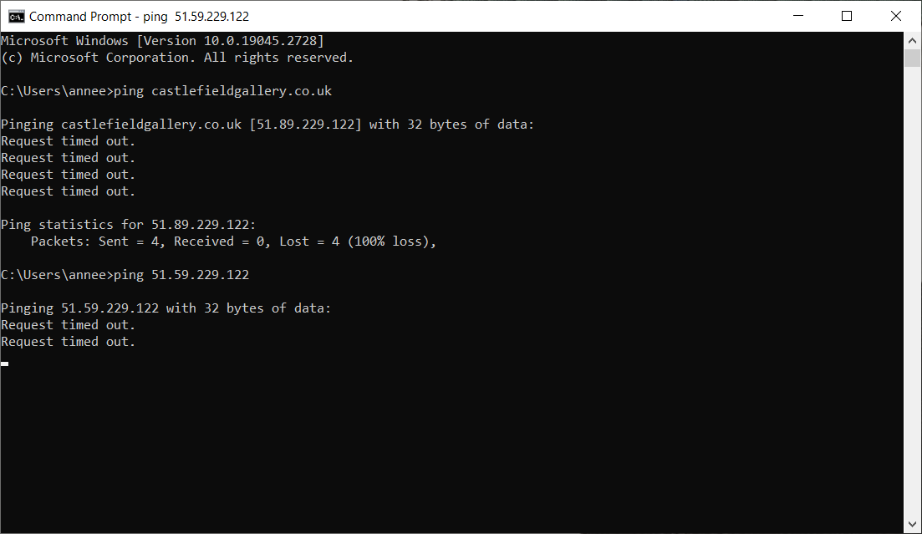

STEP 3: GEOLOCATING IP ADDRESSES

Unlike the postal system, however, IP addresses don’t point to an obvious physical place where you can dump your physical mail. There’s plenty of reasons why the folks setting up a website or network service do not want it to be thus. However, there’s also a trail of domain registration info that we can poke at to get some clues of where in the world this data might be hosted. To do so, we’ll turn to a few free look up services.

* Go to <https://www.ipaddress.com/ip-lookup>, <https://www.ip2location.com/demo/>, or <https://www.maxmind.com/en/geoip-demo>. Enter the IP into their search field.[8]

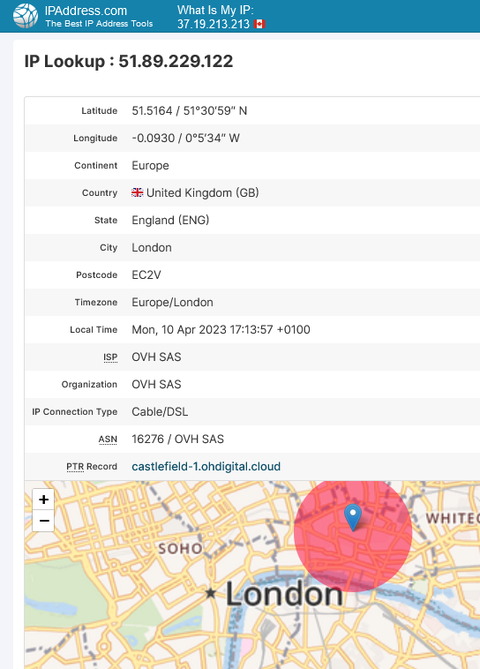

* Find the latitude and longitude (51°30′31″ N 0°5′34″ W is Castlefield’s) and enter it into GoogleMaps (or other mapping program).
* This will likely probably plunk you in the middle of somewhere without an obvious data center in view. So, with your map zoomed around these general coordinates, search for ‘data centre,’ ‘cloud,’ or ‘web hosting’ until you find a business that looks like a plausible match.

*NB:* Be skeptical of addresses located right in the middle of expensive city real estate. Unless there’s an IXP or submarine cable landing station nearby, chances are the IP address website has given you the location of the corporate offices of company that registered the website, not necessarily the location hosting its content. Sometimes, to offer a bit of privacy, IP look up tools will also simply point to the address of the closest city centre. If you’re not finding anything, or if you’re only finding financial centre boutique businesses, check your look up tool of choice for ISP (internet service provider) names. Pick up the trail on GoogleMaps with that info.

For instance, in the case of Castlefield Gallery, the geographic coordinates plunked me right in the middle of the Thames in a very posh part of London. The chances of a data center being built here are slim—I’ll need to widen my search. Looking back at my IP location lookup site, I can see that something called OVH is listed in the fields for both Castlefield’s ISP and domain. Using this as my search term points me to OVH’s London headquarters in a swanky skyscraper.[9] The company probably used this address to register their domain info, but it’s again pretty unlikely that they’ve stuffed all their servers into a pricy and fairly vertical office.

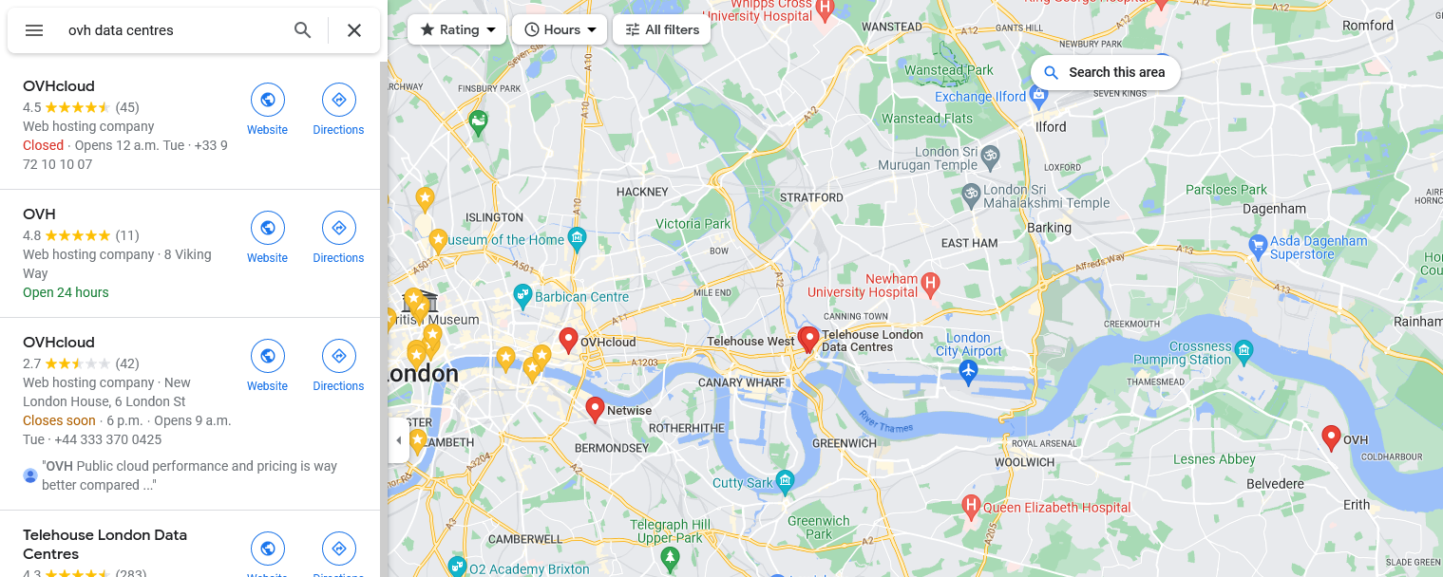

So, let’s keep looking. Zooming out of the London city center reveals another hit for OVH further down the Thames in a slightly more inglorious borough called Erith. This site is located on a one way street next to a busy traffic artery and a set of factories and distribution centers. This is much more like it! Seen on Street View, it’s an obvious match: there’s a telecommunications tower out front chock full of antennas, next to a bunch of modified shipping containers stacked on top of each other (almost surely full of server racks). Other tells include security gates, two massive power boxes with electrocution warnings, and a ‘thieves beware’ sign explaining how clever forensic devices in the cables, metals, and equipment on the site will thwart efforts to steal and sell any stolen goodies. Oh yes—we’ve got a data center on our hands. A quick search across OVH’s own website confirms that they have only one data center location in the UK, and it’s in Erith. We’ve found our match.

# Troubleshooting With Traceroute

Of course, this might not be so simple. Maybe your IP geolocation data is absolutely in the middle of nowhere, or it’s proving tricky to make the jump from the offices of the folks who registered the IP address to the digital warehouse where the digital stuff actually is. We have another trick up our sleeve: we can run a traceroute.

This is a diagnostic tool used by clever IT people (and malicious hackers) looking to trace the route data takes across the network to get from point A or point B. Internet traffic can change its paths dynamically as stuff goes offline or comes back up after maintenance, so you may not get the same results from one day to the next. In general, though, you can often find some useful hints about the sea of routers and exchange points your data moves across, all of which can help you zero in on where your target must be located, relative to the rest of your traceroute.

STEP 1: RUN YOUR TRACEROUTE COMMAND

Traceroute works by sending a message to each router in the path to reaching your destination, and then getting those routers to send little messages back to your computer identifying who they are. If all works well, you’ll end up with a list of all the steps (called ‘hops’), how long it took each of them to respond, and their IP addresses. It’s this latter information that we’re interested in, since we already have some tools to translate those IP addresses into approximate geographic coordinates. Taken altogether, this can draw a map of how your data actually moves across the planet (and thus where it ultimately comes from).

To initiate a traceroute, open up your terminal program, just like we did with ping. Then, type the following:

*For Windows Users*

* tracert [your IP address] (then hit enter)

*For Mac Users*

* traceroute [your IP address] (then hit enter)

STEP 2: INTERPRETING THE RESULT

Reading the output of a traceroute takes a bit of practice. Your computer will output a series of lines showing hop numbers, times, and IP/domain information.

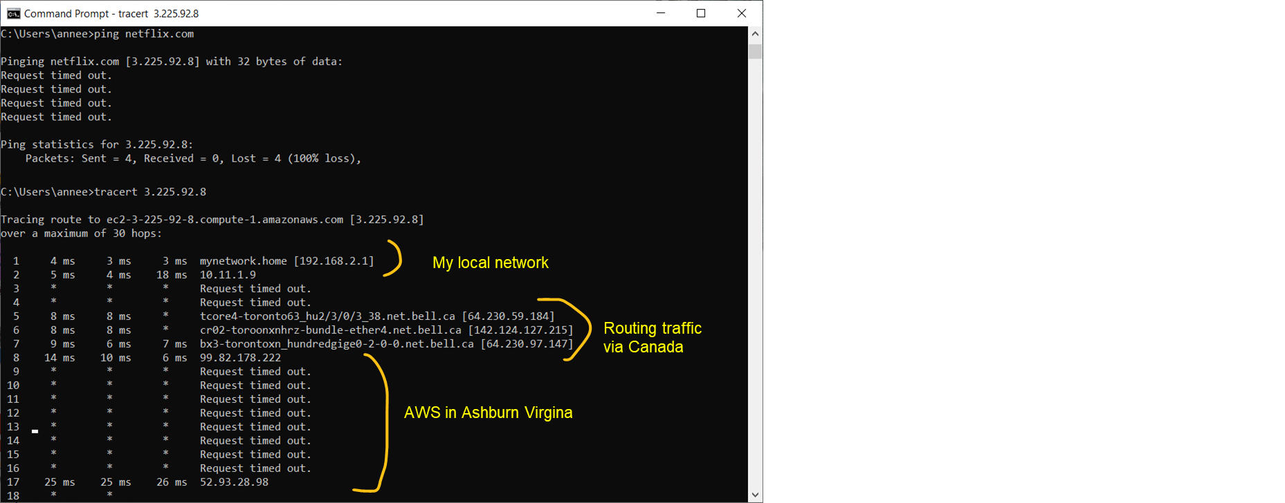

Each hop represents a location in the network that your request passes through. The first few lines are always going to be your local network with a lot of private IP addresses (and so, not terribly insightful).

Next you’ll probably hit an internet exchange point (IXP)—think of this as a bit of an on-ramp to the glorious information superhighway. These sometimes have names of cities in the information that comes before the IP addresses (or at least, abbreviations thereof. ‘Toro’ can mean Toronto, and so on).

The exciting stuff comes next: lots of seemingly random IP addresses. Try piecing together the geographic path of your data by looking up the locations of each IP address using the same tools as before. You might write down the cities in a list, or try putting down pins on a map. In this way, even if you can’t determine the location of the final IP, the path leading up to it can offer useful clues.[10]

*NB:* “* / Request times out” means that the router refused to send a message back to your computer. It happens sometimes! A lot of components in the Internet are configured to ignore traceroute prompts because they want to avoid those malicious hackers/keep traffic down. “Nothing personal,” I’m sure they’d say.

*NB:* If your traceroute won’t start, or if it looks to start from a location very far away from you, try disabling your VPN and/or any ad blockers that aren’t specific to an internet browser program. (This gets me pretty much every time).

*NB:* Running a traceroute can take a bit of time. If you want to abandon ship, or if you think things might be stalled, just hit ctrl c simultaneously to stop.

# Once you’ve found your data centre:

Congrats on using neat network tools to find your digital whale! But now that you know where and what it is, it’s time to learn a little more about the local political story of your leviathan.

SOME TIPS FOR GETTING THE GOSSIP:

* Try visiting it via Google Street View (potentially comparing image captures from different years).
  1. Does it announce what it is, or try to blend in with its surroundings inconspicuously?
  2. Has the site changed much over the years?
  3. How heavily secured does it seem to be?
  4. Does it follow along/terminate in a path for goods and information built in a prior era (a colonial port, rail network, or pipeline)? Or is it built smack in the middle of nowhere?
* Read its reviews in Googlemaps. Do people complain about the noise/security?
* Search for it (or for data centers in the region) in the news (<https://news.google.com>). Experiment with adding keywords like ‘energy,’ ‘consultation,’ or ‘policy’ if you get too many hits.
* On the basis of all this, ask yourself some questions:
  1. What potential land use, energy, or water conflicts might exist because of the data centre?
  2. How clean do you think its electrical use might be? How vast?
  3. Why was it built where it was?
  4. Who benefits from the data center being here? Who loses?

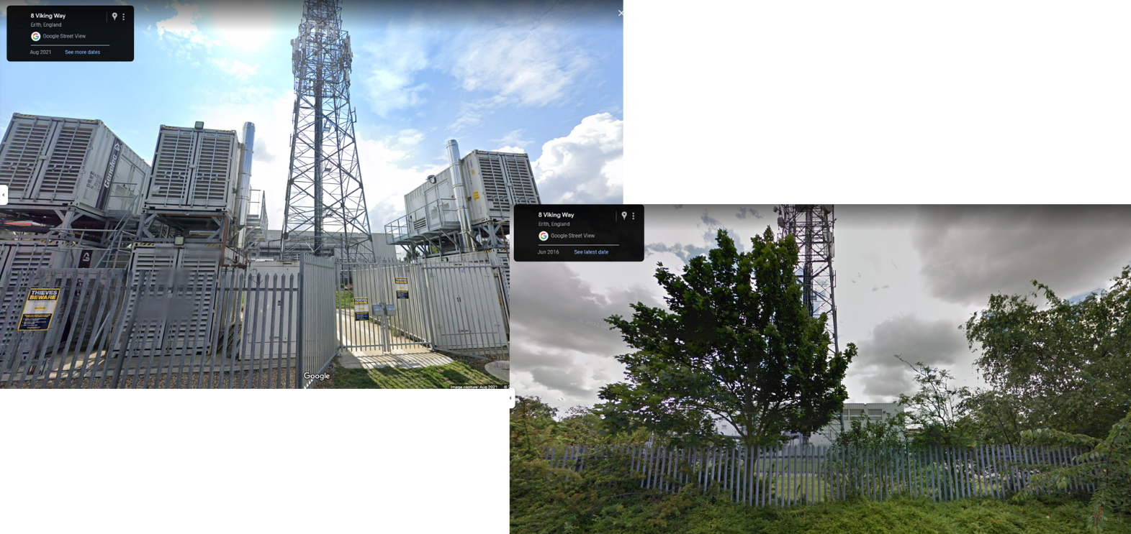

To go back to our example of Castlefield Gallery, this digital sleuthing reveals that security on site is a little tight, and also that it’s undergone a recent expansion (all the containers out front appeared sometime after 2016). Snooping around news sites and press releases helps explain why: OVH expanded its Erith site post-Brexit, anticipating that there would be demand for more national data services in a Britian that was no longer a part of the EU (thus EU data privacy laws). So, all these boxes of servers and electrical transformers, in part, owe their existence to the Leave campaign.



This is all interesting (or, at least, it is to nerds like me), but maybe not a boiling political fight. Sometimes, however, you do find exactly that.

# What do data center conflicts look like?

Let’s look at Netflix. If you live in the Eastern United States, a good part of your streaming content probably sits in the data centers Netflix leases from Amazon in Ashburn, Virginia. Following the IP (99.82.178.222) takes you to a mega complex on Gloucester Parkway. It’s about the size of a small neighbourhood, and is stuffed full of cooling vents and electrical equipment.

Zoom out and you’ll find lots of similar complexes in the area. North Virginia is called ‘data center alley’ because there’s so many of these things lying about.[11] The expansive growth of data centers here looks like “[suburban sprawl on steroids](https://www.virginiamercury.com/2022/12/09/virginia-has-a-data-center-problem/),” resulting in deforestation, rainwater runoff problems, and worsening air quality. It’s also gotten to the point where these facilities are bumping up against residential areas, where the loud and constant noise of all those cooling fans are causing [headaches and sleeping issues](https://www.washingtonpost.com/dc-md-va/2023/02/10/data-centers-northern-virginia-internet/) for some. They’re also poised to strain the electrical grid with all their AC requirements during this year’s summer months. In response state regulators have toyed with [issuing special exemptions](https://www.virginiamercury.com/2023/01/31/va-regulators-propose-easing-emission-limits-for-data-centers-over-power-transmission-concerns/) to let data centers run diesel generators to boost their power intake (but also the air pollution and climate impacts of these facilities). Data centers don’t make for good neighbors.

To be fair, sometimes the press also has positive things to say about tech development and climate change. Data center companies are [leading a wave of green power purchasing agreements](https://think.ing.com/articles/american-big-tech-goes-green-and-drives-ppa-market/), helping to bring new renewable energy sources onto the grid. (I’m particularly enthused about efforts like Google’s [24/7 Carbon-Free Energy](https://www.google.com/about/datacenters/cleanenergy/) plan, which is pushing grid operators to get way more granular about the challenges and potential solutions of a future where we have more renewable power on our grids, and thus a lot more dynamic shifts between supply and demand to balance out).

These are laudable goals; however, green power isn’t always an unqualified good. [Julia Velkova](https://rustlab.ruhr-uni-bochum.de/across_layers/#abstract-velkova2), for instance, has been tracking how one particular case of Google’s renewable power purchasing efforts has become embroiled in [land use conflicts with Sami](https://ejatlas.org/conflict/large-scale-wind-farm-in-sami-reindeer-pastures) people in Sweden, who stand to lose access to traditional grazing lands with the construction of a wind power park. They’re calling it "[green colonialism](https://www.business-humanrights.org/en/latest-news/sweden-locals-protest-wind-energy-construction-due-to-concerns-over-impacts-on-sami-reindeer-grazing-lands/)."

It’s also the case that the simple math of data center growth and green power ambitions may not always be reconcilable. Ireland, a major tax loophole jurisdiction and thus home to many of Europe’s data centers, is an instructive example. A wave of newly planned data centers are set to far outpace electrical supplies in the country. If all proposed data centers were actually built, the sector could consume up to [70% of Ireland’s entire electrical capacity](https://www.irishtimes.com/news/politics/data-centres-could-use-70-of-ireland-s-electricity-by-2030-committee-to-hear-1.4685589) by 2030. It’s hard to imagine that demand being met entirely by new renewable energy developed on this timeline. If it were, all those solar and wind parks would still need to go somewhere, likely stirring up further [community and land use conflicts](https://www.thejournal.ie/readme/climate-change-and-data-centres-5392847-Mar2021/). More fundamentally, though, if we’re only adding new green capacity to our grid to meet new demand, we will continue to fail to make a dent on our wider decarbonization goals. We need more than just a green licence for new growth, we need to slash the carbon-intensity of the grid as it stands.

Elsewhere, fights with data centers might look more like conflicts about the kinds of landscapes and livelihoods that we value as a culture. In the Netherlands there has been an upwelling of resistance against data center expansion, all of which eventually culminated in a [nation-wide moratorium](https://www.datacenterdynamics.com/en/news/dutch-government-halts-hyperscale-data-centers-pending-new-rules/) on new data center construction and a change of federal power. Opposition here was initially derived in part from [contested water rights](https://www.datacenterdynamics.com/en/news/drought-stricken-holland-discovers-microsoft-data-center-slurped-84m-liters-of-drinking-water-last-year/) during a drought and concerns around [democratic deficits in infrastructural permitting](https://doi.org/10.1177/14614448221145928). More boisterously, these efforts were joined by a rural farmer movement united in their dislike of how data centers have encroached into rural landscapes. As one leader puts it, “It is [a waste of fertile soil](https://www.wired.com/story/microsoft-netherlands-hyperscale-data-centers/) to put the data centers boxes here.” Together this was enough to win elections.

# So How Do We Get Into Fights with Data Centers?

As these examples show, struggles to halt data center expansions can take many forms. Sometimes, like the Dutch, you might take control of the government. In other instances, more modest goals could be the priority: organizing neighbours, getting media coverage, and pushing for increased regulatory scrutiny.

If there’s already a movement forming around opposition to your data center of interest, plug in. Join groups, show up to meetings, or offer your solidarity and support from afar. If there isn’t yet a group, trying organizing one.[12] Start a Facebook group, write a letter to the editor of a local paper, start a conversation on a city subreddit, chat up your contacts in the area, and maybe build towards getting a resolution passed by a local civic association, labor union, or city council.

With enough people, you can explore more creative tactics. This might involve spectacular (and thus media-friendly) protests like Extinction Rebellion Ireland’s amazing [vampire-themed demonstration](https://climatecampireland.ie/2023/05/19/vampire-themed-data-centres-protest-and-walking-tour-from-amazon-to-misery-hill-this-sunday/) against Meta’s data centers. In other contexts, you might work on a project of citizen science data acquisition, like [researchers at Cornell](https://rc.infosci.cornell.edu/2022/03/10/bitcoin-mining-in-upstate-ny/) who are experimenting with tactics like duck decoy drones to collect data about the thermal impacts of bitcoin mines in the Finger Lakes. Even more inventively, you could explore tactics like working to [cut off water](https://www.theguardian.com/world/2014/feb/12/utah-lawmaker-nsa-data-centre-water-supply) rights to existing data centres (like, say, those run by the NSA) or [building charmingly low-tech alternatives](https://computingwithinlimits.org/2021/papers/limits21-abbing.pdf) to the hyperscale cloud.

Anti-data center efforts can also learn a lot from previous movements fighting to curtail unwanted developments of all kinds. The [history of pipeline opposition](https://grist.org/fix/advocacy/how-activists-shut-down-key-pipeline-projects-new-york/) is one illuminating and obvious example. These activists demonstrate how researching key permitting procedures, environmental impact requirements, and [key political actors](https://doi.org/10.1016/j.erss.2022.102914) in development decisions are all essential steps, as are forming wider coalitions of different groups to stand with you. At times, these might make for strange bedfellows. For folks fighting fossil fuel infrastructures, this has meant a mix of NIMBYs, frontline environmental justice communities, anxious climate weirdoes like me, local businesses, and tourists. Not everyone will be there for the same reason, and not everyone will necessarily even believe that climate change is a serious issue. (In the case of the Dutch protesters, for instance, many farmers were initially mobilized *against* climate regulations on their farms).

That said, we don’t yet know what the full span of data center opposition politics will or should look like. As [Julia Rone](https://intellectdiscover.com/content/journals/10.1386/jem_00086_1) argues, in order for local victories to scale up to wider changes, there will need to be more transnational conversations about organizers’ strategies and experiences. The hazard, of course, is that a data center project might be shoo-ed away from one municipality, only to take up shop in another, perhaps more distant location. Stopping a project here doesn’t mean that it won’t be built elsewhere. This means that a final (and probably quite essential) way you can get into fights with data centers is to help with the work of archiving and sharing many different local efforts. This zine aims to be a small contribution to this end.

# But what could we win?

The prizes here will look as different as the coalitions that gather around them.

To folks like me, two major reasons to grapple with data centre expansions include wider climate trajectories and political suspicions about the world endless data storage is slowly building. Setting limits on digital infrastructure—or even beginning with the assumption that what we currently have might already be sufficient—could help foster a culture of technical maintenance and repair over and above an emphasis on innovation (regardless of the social or climate costs). It would be great to learn how to be better stewards of what we’ve already built instead of playing regulatory catch up with the infrastructural and digital monsters that lurk on the horizon. Plus, again and with emphasis, this climate change thing is pretty bad. We should do something about it.

To those living in the shadow of data centers, however, I suspect the rewards will be a little more immediate and tangible: being able to open your window without being overwhelmed by whining fan sounds, lessening the load on your groundwater during a drought, keeping farmland fertile, reducing the risk of black outs and rate hikes, and ensuring that the businesses that do set up shop in your city actually pay their fair share of taxes.

Regardless of the outcome, I strongly suspect that this path will also bring its share of rewards through the very process of struggle. These are in part analytic. By being clear about the need to reduce sectoral emissions, rather than just increase efficiency, we can avoid slights of hand that obscure fundamental differences in scale or emphasize the wrong sorts of metrics. Staying grounded in the infrastructural side of things also ensures that we can hold the climate story in hand along with a range of other social and economic impacts, keeping local concerns in tandem with global perils. We need both to really turn the corner on this one.

But, to return to the anxious folks asking me questions about their carbon footprints at the start of this zine, I think there are serious [emotional](https://doi.org/10.1177/20563051231177906) dividends to be won in the work ahead if we focus on stopping the next data centre from being built. Instead of feeling guilty about the climate impacts of our own online habits, or scowling at crypto or machine learning bros who are seemingly oblivious to their own, we could put that energy towards concrete and bounded targets: stuff we could actually win. It feels good to organize under a framework that doesn’t require you to meet impossible ethical standards, to only ever *do less*. Instead, you could find ways to *do more*, applying yourself to a constructive project. Plus, this way you don’t have to convert everyone you meet to your exact point of view. You can, instead, find friends where you will, develop the skills you’re interested in fostering, and be a part of building something bigger than yourself.

So, please take me quite sincerely when I say: Happy fighting out there. Good luck.

1. Here’s a few to try if you’re curious: <https://ecotree.green/en/calculate-digital-co2>; <https://thenetworkedcondition.com/form/development>; <https://www.websitecarbon.com/>.
2. Maybe I should be specific about what and who I’m calling out here? [The Shift Project](https://theshiftproject.org/wp-content/uploads/2019/07/2019-02.pdf) is a French non-profit that’s been active in the digital-climate sphere for a while now, and with some pretty apocalyptic predictions for the future state of things. They anticipate that we’ll need to drastically constrain the legal liberties of ICT companies in the future if we want to avoid climate catastrophe, and so call for wider social debates about the kinds of content that should be first on the chopping block when it comes time to set limits (so, you know, we’ll be ready to ban that bad stuff). In particular, they go out of their way to suggest that online porn is worth particular scrutiny. But, as a feminist who takes a lot of cues from sex workers struggling for better working conditions, I am pretty worried about where that line of thinking might take us. This isn’t to say that I think that all online content is equally valid (for me, I’d put ad tech, bitcoin, and a lot of AI on the chopping block), just that I strongly suspect that starting from the perspective of what we want to ban leads to a very different—and I fear, less successful—political project than discussing what kinds of physical structures we do (or do not) want to build.
3. [I wrote a book](https://www.upress.umn.edu/book-division/books/digital-energetics), in part, about the limits of efficiency as an environmental strategy. In brief, you can be incredibly efficient and have tons of renewables going into your facilities but, if your growth outpaces your savings, the problem is still getting worse! Plus, [researchers have shown](https://doi.org/10.1177/2053951720982032) that splashy green AI efforts by big companies are often first and foremost a PR effort. Let’s not let a little green good take our eyes completely off the prize of those wider climate targets.
4. Maybe you’re a tech worker or academic? By all means, read on, but I hope you’ll also think about the specific opportunities that are unique to you, your domains of expertise, and your labor conditions. These could all well be better uses of your energy than where I go with this zine. You’ll know better than me!
5. Maybe not as much as the IT folks on call working underneath them, granted.
6. I’ve previously tried to map out some of these [differences in scale](https://app.mural.co/t/digitaldecarbworkinggroup0285/m/pg2r6875/1652626129862/d607208a1fe0ad8caa1fd504f2be440fea4ac1c7?sender=u20c186cd514534b4a32b2135). Again, I’ll repeat my caveat about the precision of these sorts of footprinting numbers, but I think it’s useful to make these comparisons when they help illuminate what’s really a difference in kind, not just degree.
7. Here I’m specifically talking about IPv4 addresses, but the Internet is slowly moving to a different format: IPv6. Your terminal commands may need to [look a little different](https://www.hacksparrow.com/networking/ping-ipv6-address.html) to successfully knock on these digital doors.
8. An alternative here is to enter curl ipinfo.io/[your IP of interest] in your terminal program.
9. When poking around a site I like to use Google Street View to confirm whether or not the vibes are off. Anything with outwards facing glint (sleek windows, lobby art, a property manager’s stylish website for prospective tenants, etc.) or even just a fair bit of height is cause for suspicion. Your data center is much more likely to be a beige, sprawling warehouse, fenced off from the world (but also trying to look sort of unassuming about it).
10. If you’re still stuck, or if you want to cross reference, a few other tools you could play around with are <https://traceroute-online.com/mtr/>, <https://geotraceroute.com>, or <https://hackertarget.com/online-traceroute/>. I personally find them a little more error prone and hard to parse, but you might be built different! You could also try on a different day (and so maybe a different route through the network).
11. There are so many really interesting reasons for why this is the case: the tax breaks here are especially good, it’s close to DC (and thus lucrative military contracts with low latency requirements), it’s a coastal region with lots of subsea cables running to Europe and a relative lack of hurricanes, there’s lots of empty factories with good preexisting electrical infrastructure because of waves of deindustrialization, and a bunch of fiber got laid across the state with regional development funds that came from lawsuits against the tobacco industry for the whole ‘lying about cigarettes causing cancer’ thing. Life (and the politics of infrastructure) can take strange turns.
12. Are you new to community organizing? It’s one of those often difficult, but really rewarding and sort of essential human skills. Like any skill, anyone can learn how to do it and it takes a lot of practice to build up your confidence and instincts. For a good place to start, I recommend the [Rebel Steps podcast](https://rebelsteps.com/season1/) or [Labor Notes’ union organizer materials](https://labornotes.org/secrets/handouts) (most of which can be adopted outside of the union context).